The Glorified Christ
Revelation 1:9-20

I. We should be committed to His purpose. (v. 9-11)

“in the Spirit” (Revelation 1:10; 4:2; 17:3; 21:10)

“the Lord’s Day” (Matthew 28:1; Mark 16:2, 9; Luke 24:1; John 20:1, 19; Acts 20:7; 1Corinthians 16:2).

“I am Alpha and Omega, the First and the Last” (Isaiah. 41:4; 43:10; 44:6; 48:12; Revelation 21:6; 22:13)

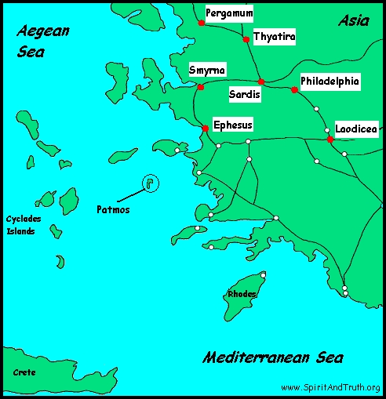

“write” (Revelation 1:19; 2:1,8,12,18; 3:1,7,14; 14:13; 19:9; 21:5)

“great voice…sound of a trumpet” (Exodus 19:16)

II. We should be in awe of His person. (v. 12-17a)

“seven candlesticks” (lampstands) (Exodus 25:31-40; 37:17-24; Zechariah 4:2,10)

“One like the Son of man” (Daniel 7:13-14; Mark 14:61-62)

“in the midst” (Matthew 28:20; Hebrews 13:5)

“robe” and “golden girdle” (Exodus 28:4; Hebrews 7:1,25; 9:11-12; 4:15)

Verses 13-15 (Daniel 7:9)

“white” (1 Timothy 6:16)

“eyes” (Matthew 10:26; 1 Corinthians 3:11-15; Hebrews 4:13; Revelation 2:18; 19:12)

“feet” (Psalm 110:1)

“voice” (Ezekiel 43:2: John 5:28-29; Revelation 14:2; 19:6)

“right hand” (Matthew 28:18; Colossians 1:18; John 10:27-28)

“mouth” (Matthew 17:5; Hebrews 4:12; Revelation 2:12,16; 6:8 19:15,21)

“countenance” (Judges 5:31; Exodus 33:18-23; 34:29-35; 1 Timothy 6:16)

“fell at His feet” (Isaiah 6:5; Daniel 10:7-9; Luke 5:8)

III. We should be encouraged by His Word. (v. 17b-20)

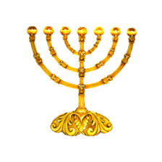
“He that liveth” (John 14:6; Hebrews 7:25)

“keys” (Matthew 16:18-19)

“hell” (Matthew 16:18; Luke 16:23; Acts 2:27,31;
1 Corinthians 15:55; Revelation 20:13-14)

“death” (Hebrews 2:14-15; Philippians 1:23; 2 Corinthians 5:8)

“angels” (Hebrews 1:14; James 3:1)

